Shell

1.

Step 1: open nano editor to write desired shell script by writing command ***nano filename.sh***

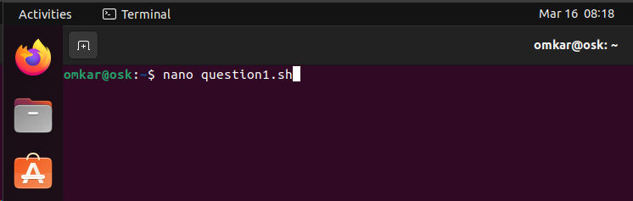

Step 2 : writing the code in nano editor

Logic : first used if else block to apply conditions

Compared first number with other 2 by using -gt and && functions

Same process repeated with 2nd number

In else block the remaining number will be the largest

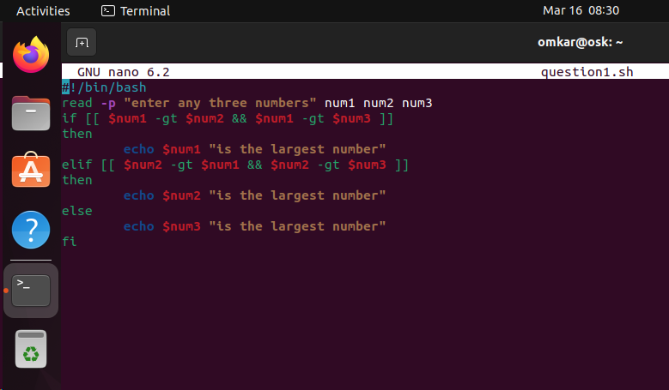

Step 3 :run bash filename.sh command to execute the script and check results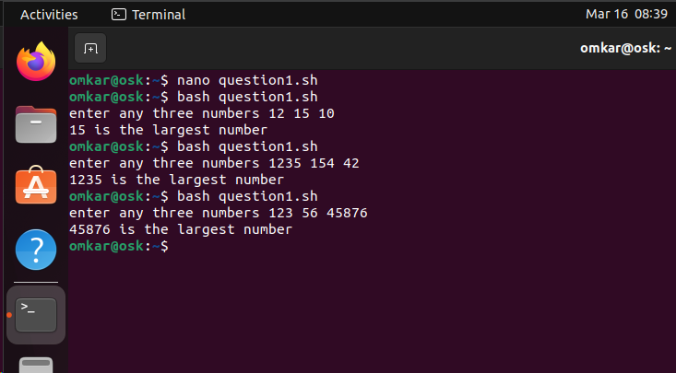

Question 2

Step 1 : 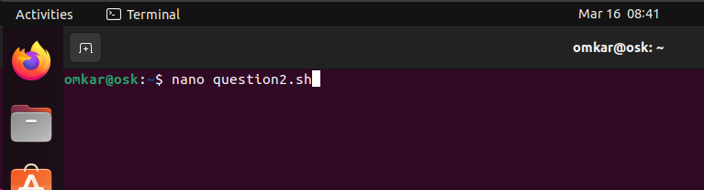

Step 2: write code in nano editor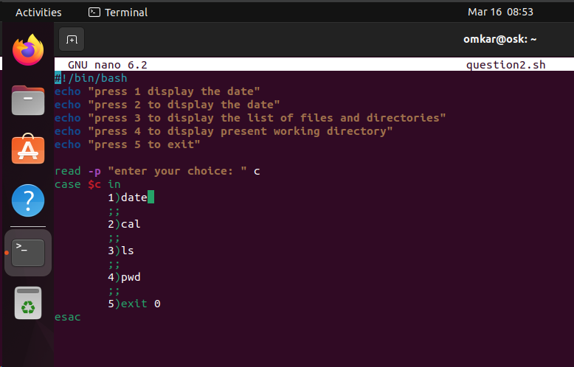

Step 3: execute and check results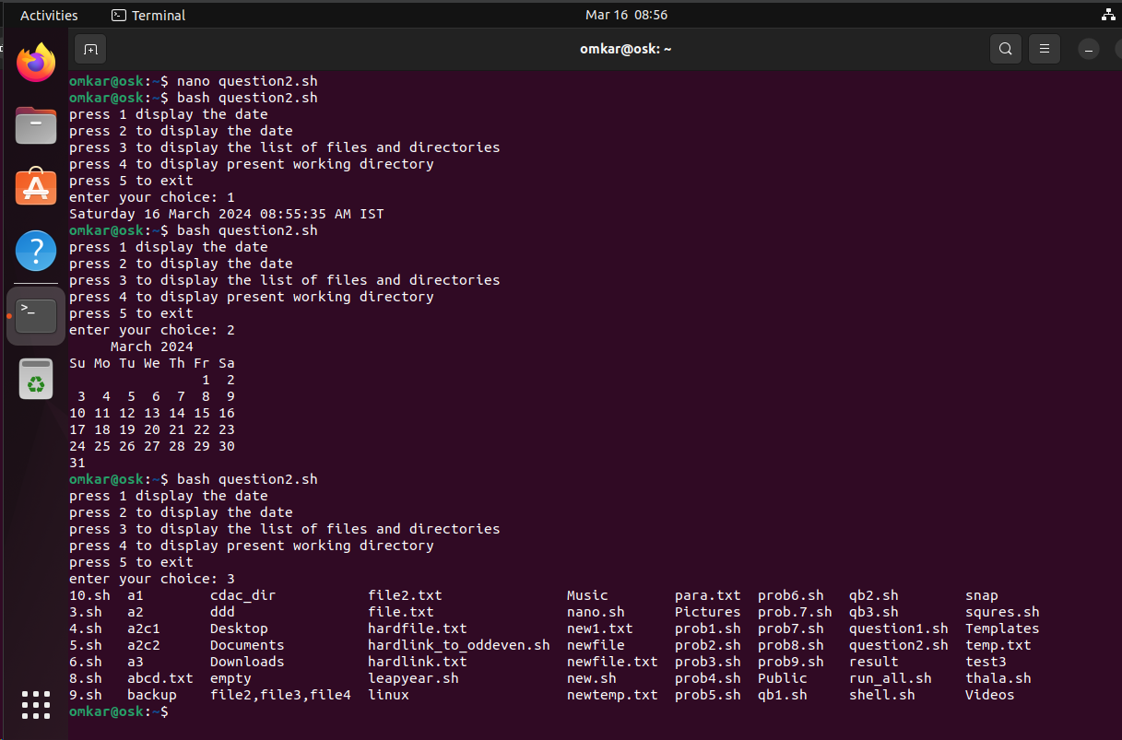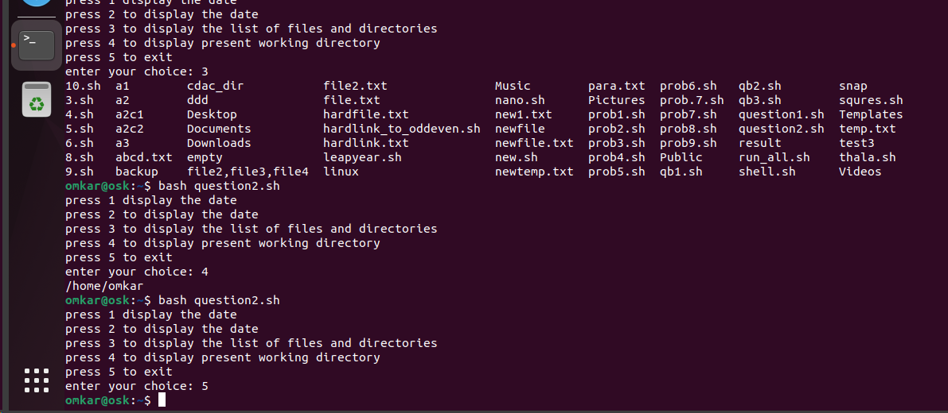

Question 3

1.

Created directory using mkdir command

mkdir exam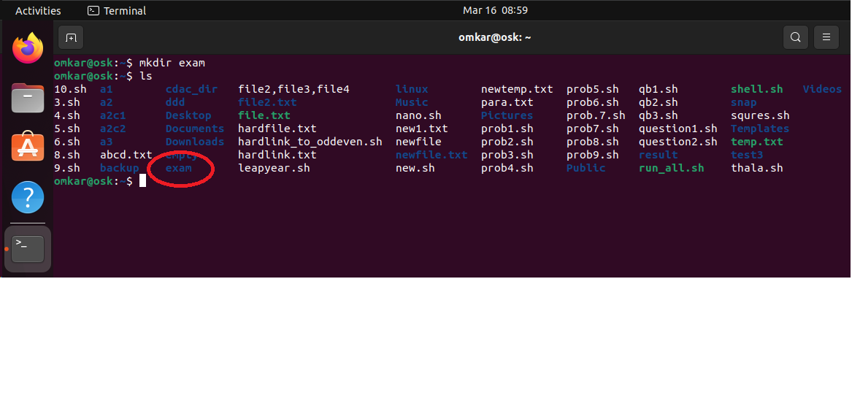

Used ls to list files and directories and checked if directory created successfully 

Question 3 B )

Step 1 : mv exam newexam

used

Ls command to check

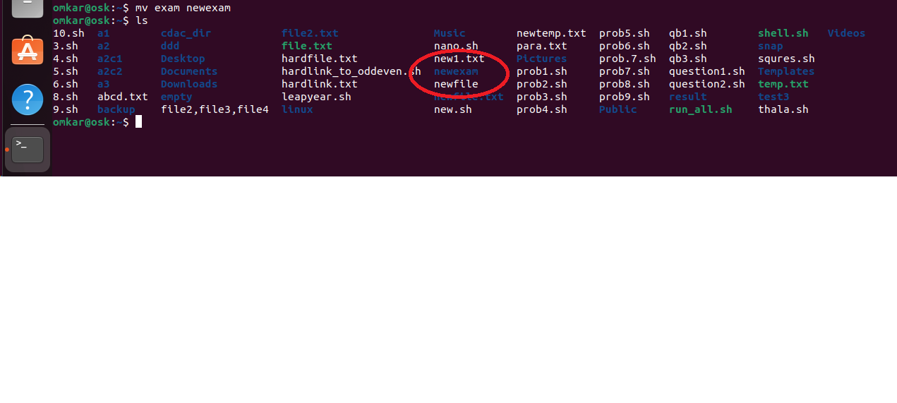

Q3 c

step1Used mkdir command to create new directory

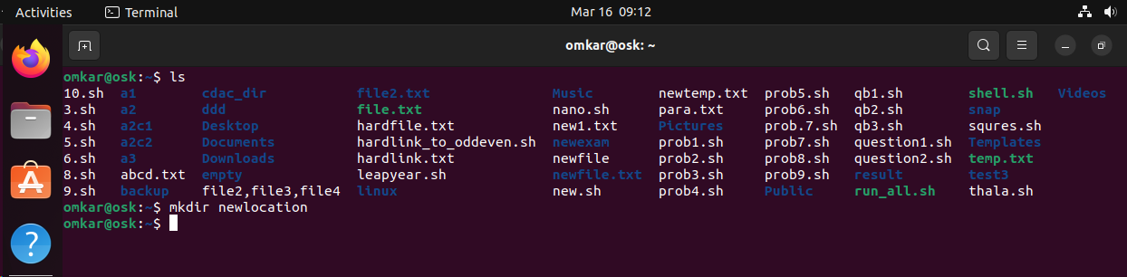

Step 2 : used mv newexam newlocation/

After giving ls command the “newexam” directory is no longer present in home page

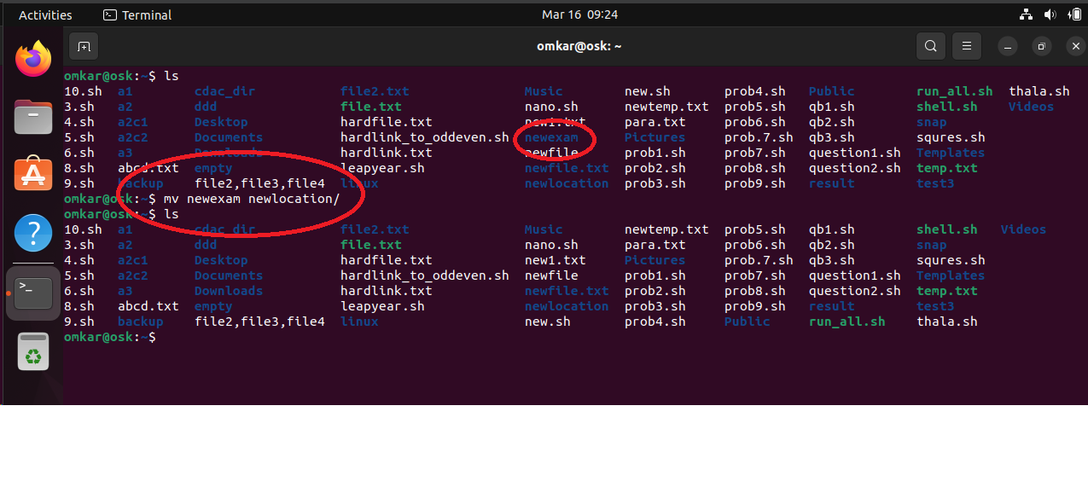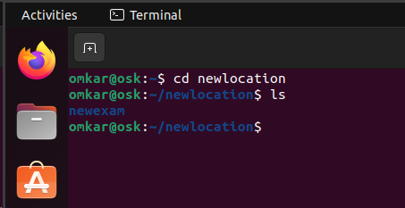

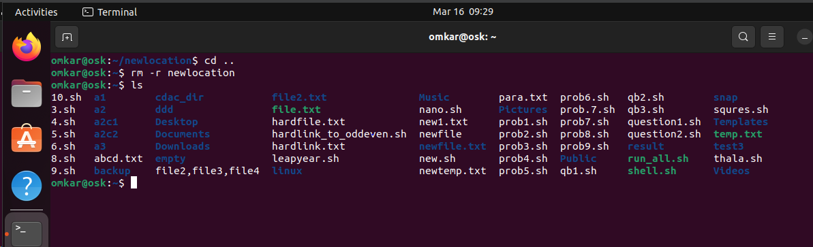

Cloud

Step 1 : 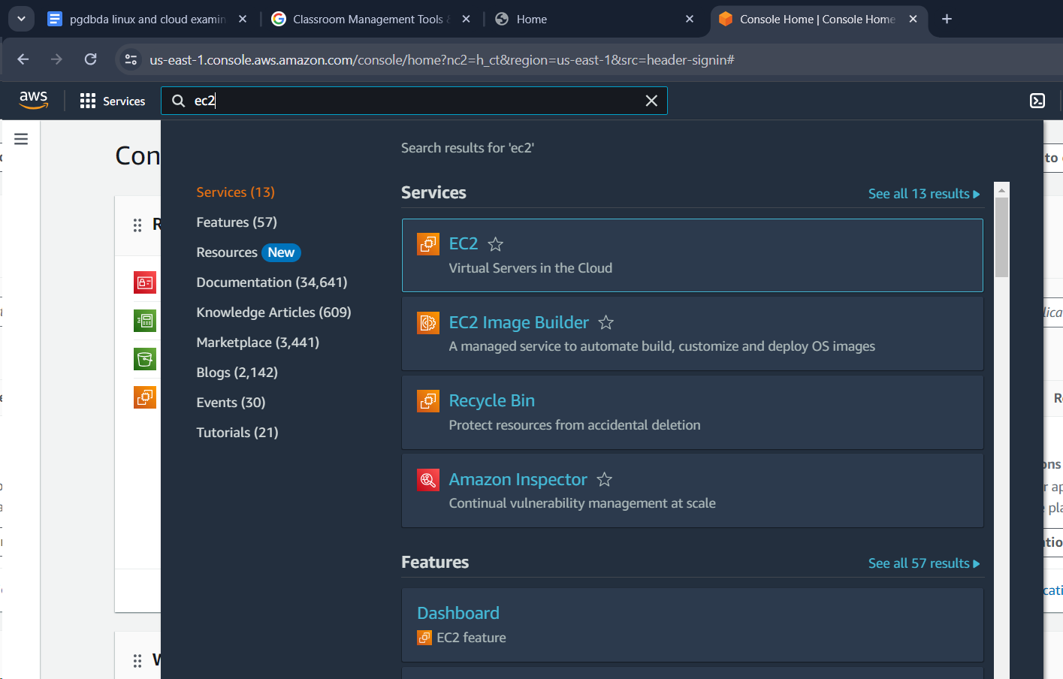

Step 2 : launching instance

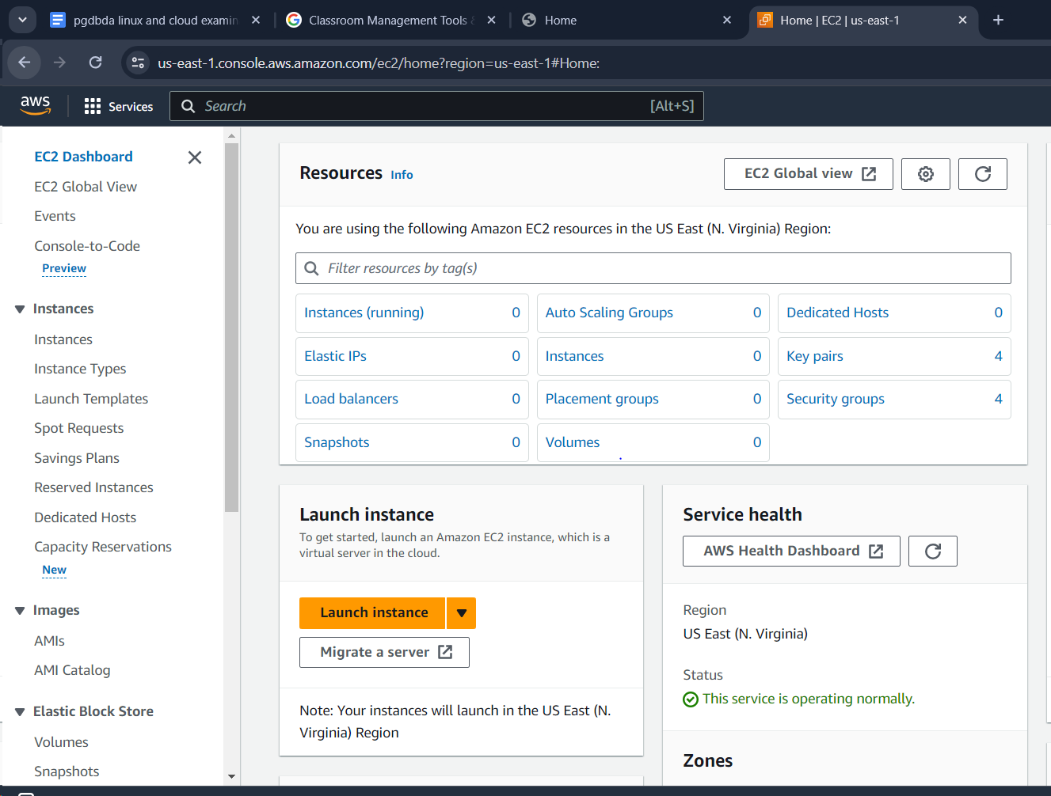

Step 3

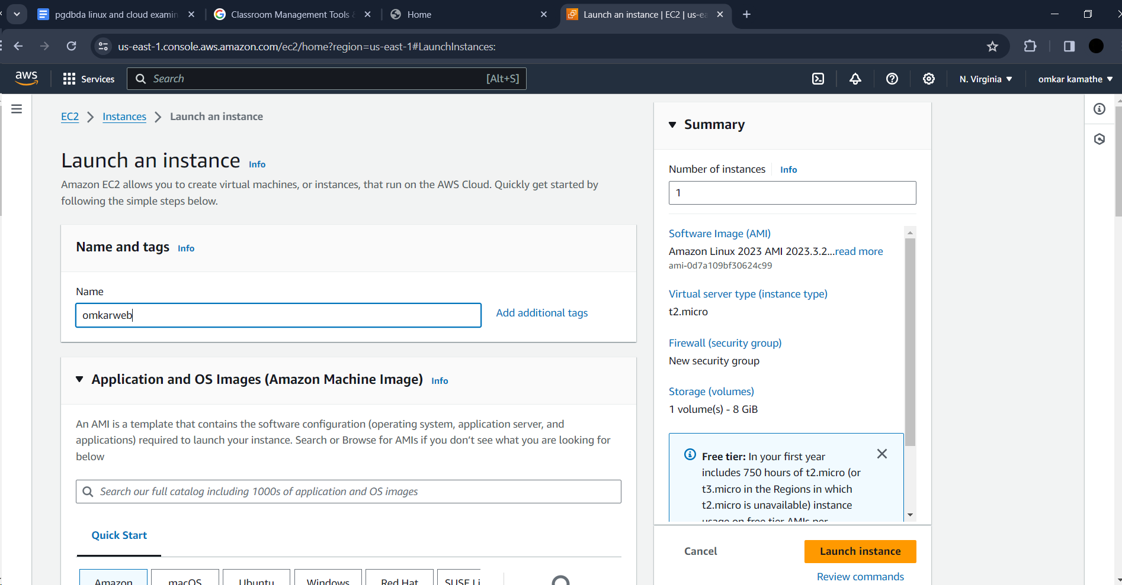

Step 4 allow http traffic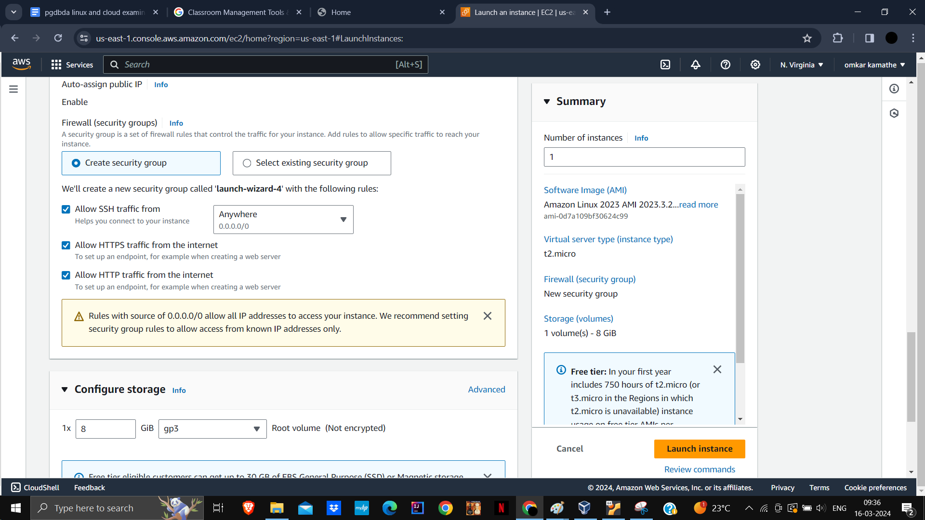

Step5 create key pair and choose ppk and give keyname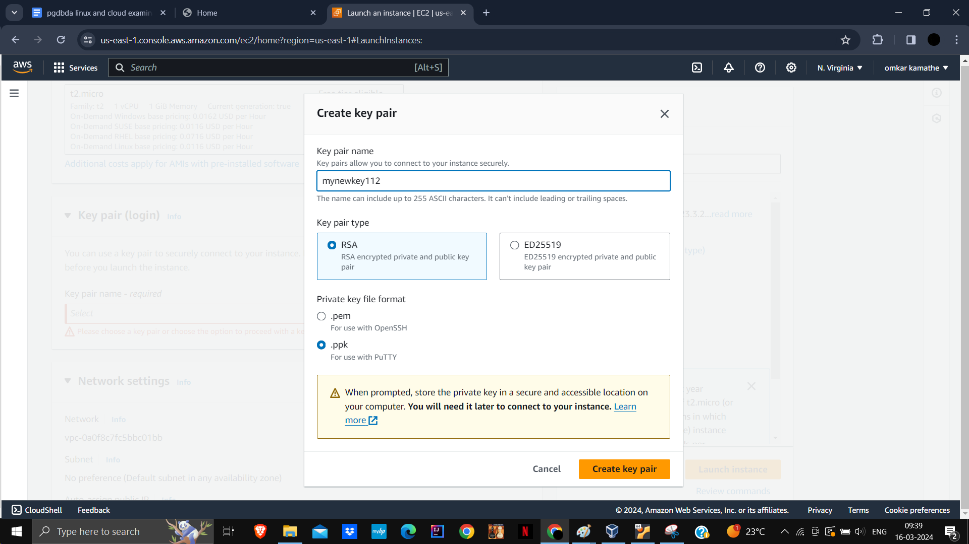

Ppk file downloaded

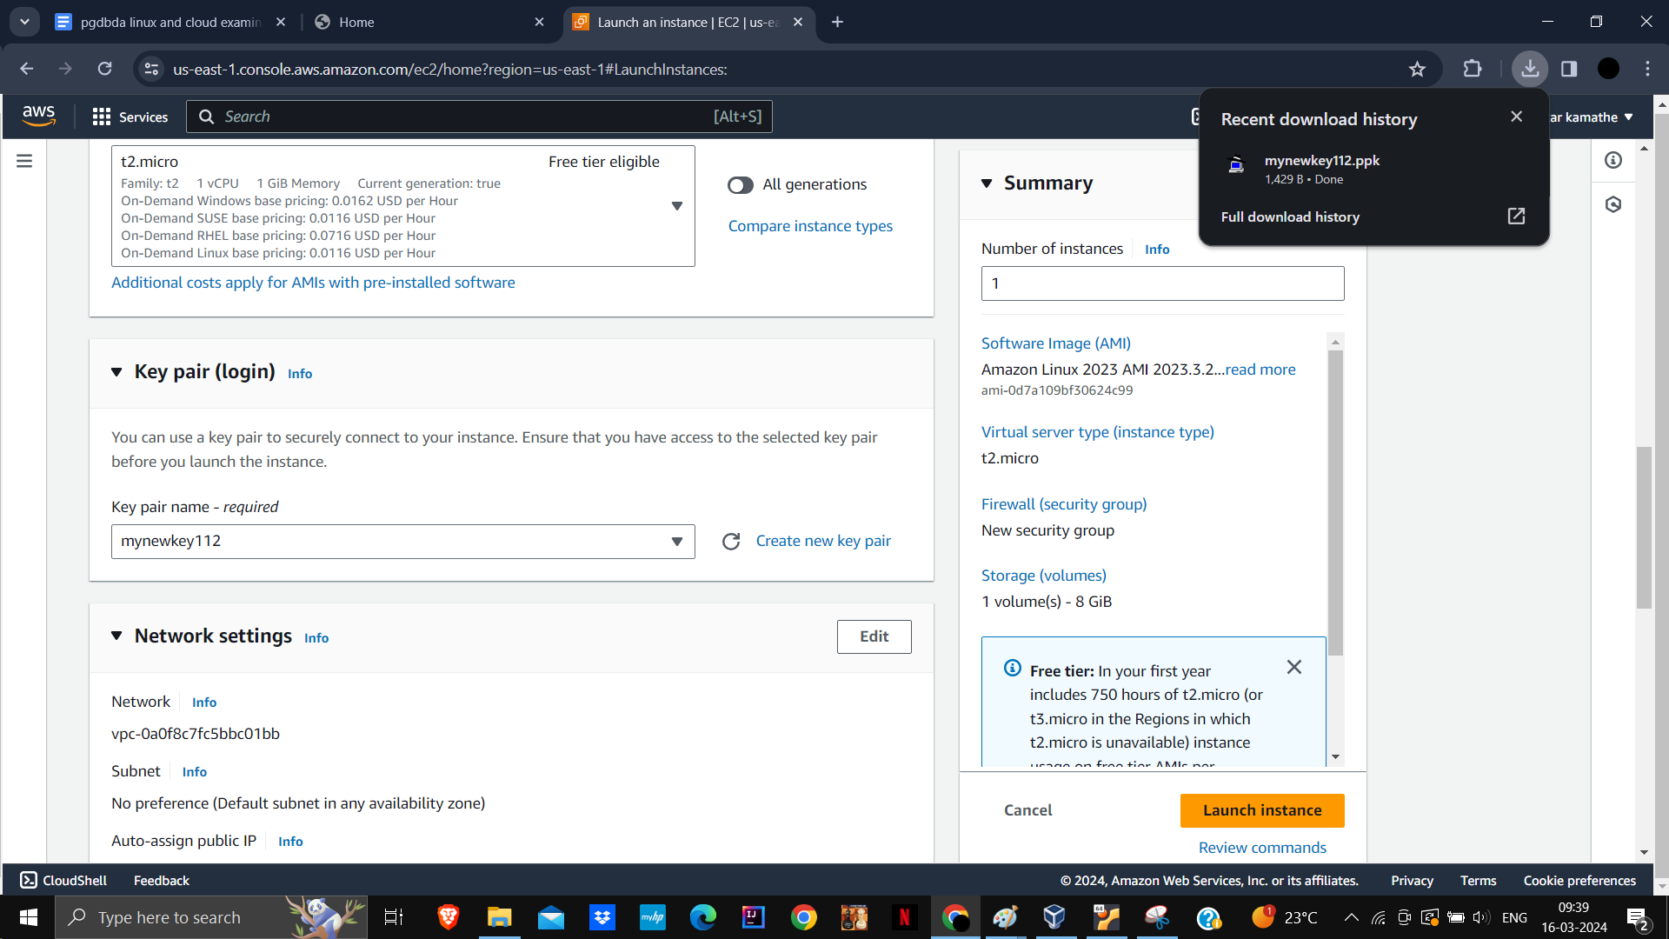

After clicking on launch instance , instance created

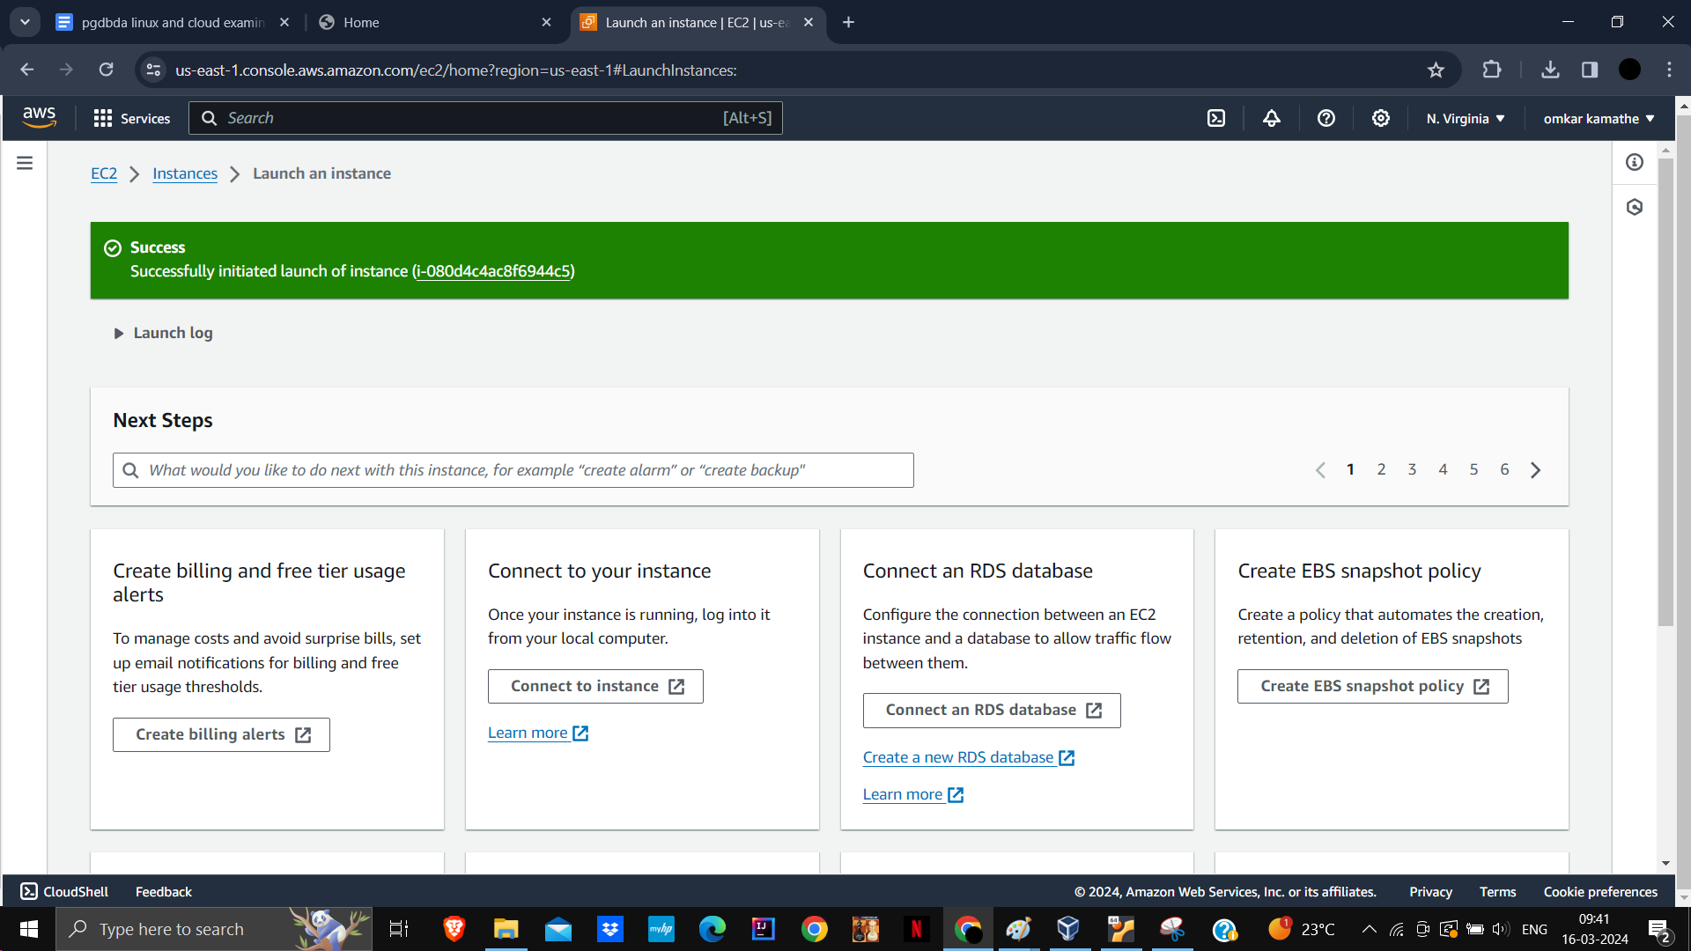

Copy public ip address and paste on hostname as ec2-user@ipadress

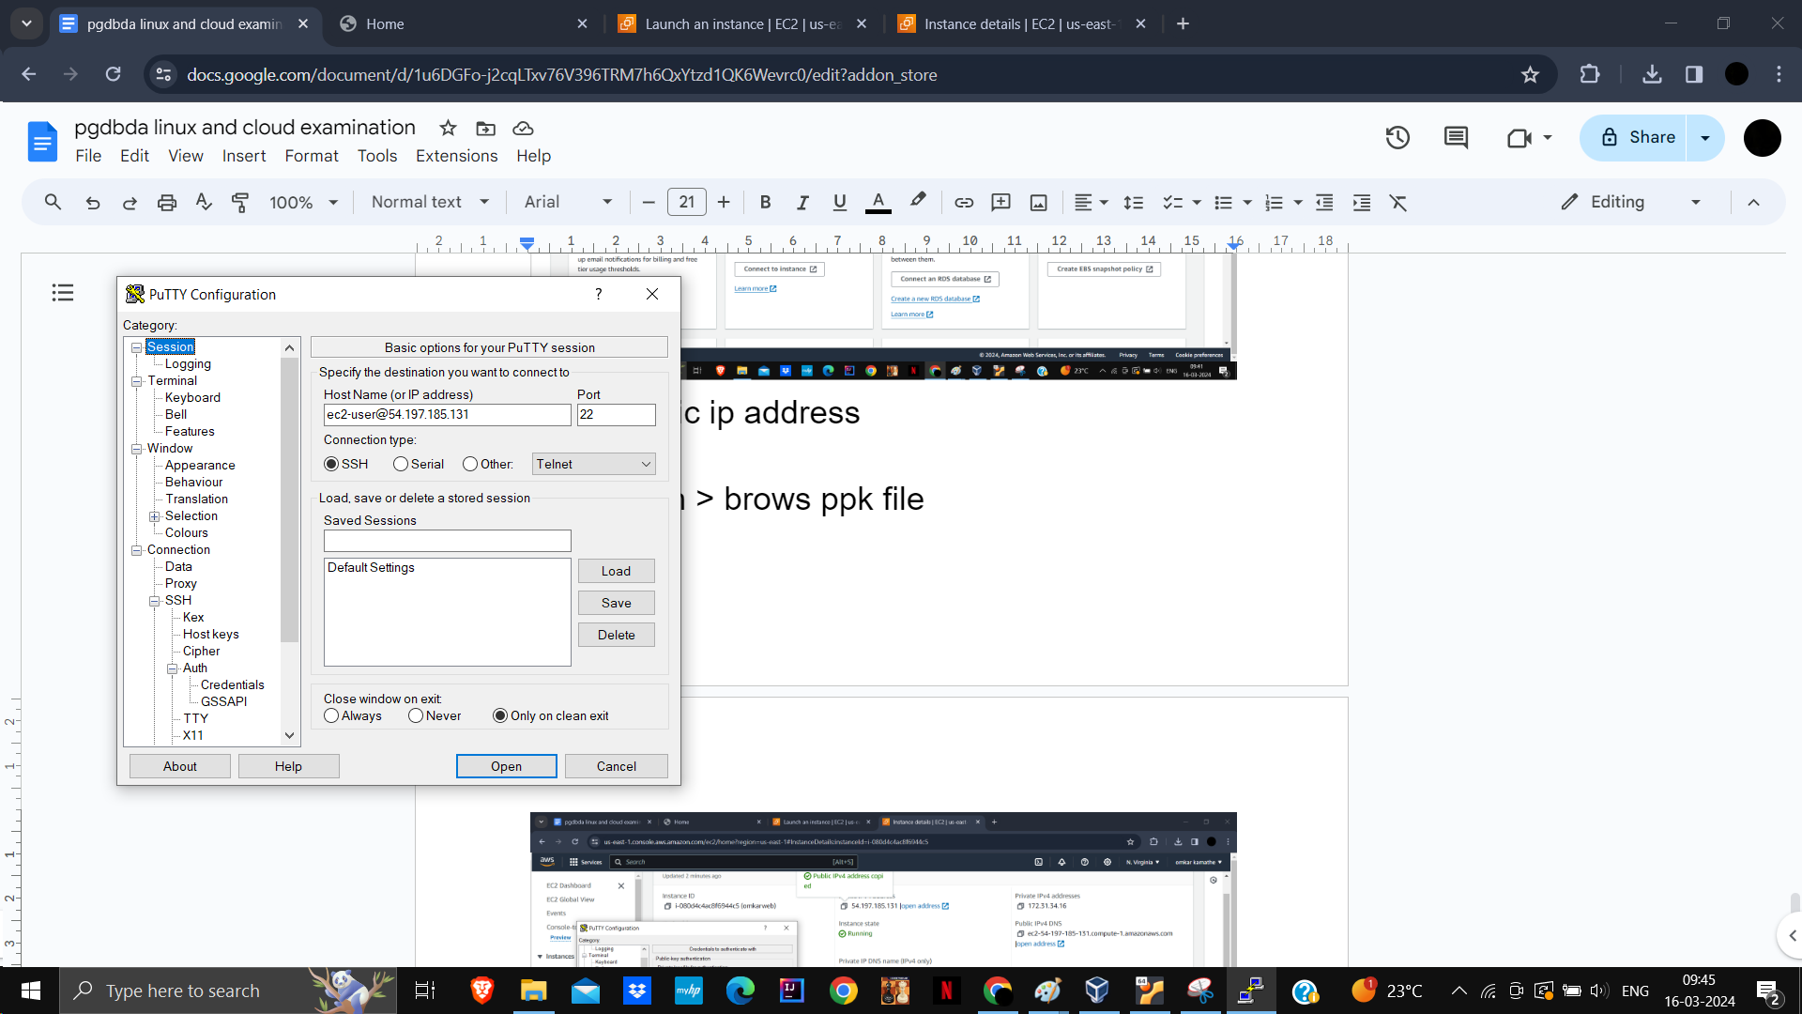

Ssh > auth > brows ppk file

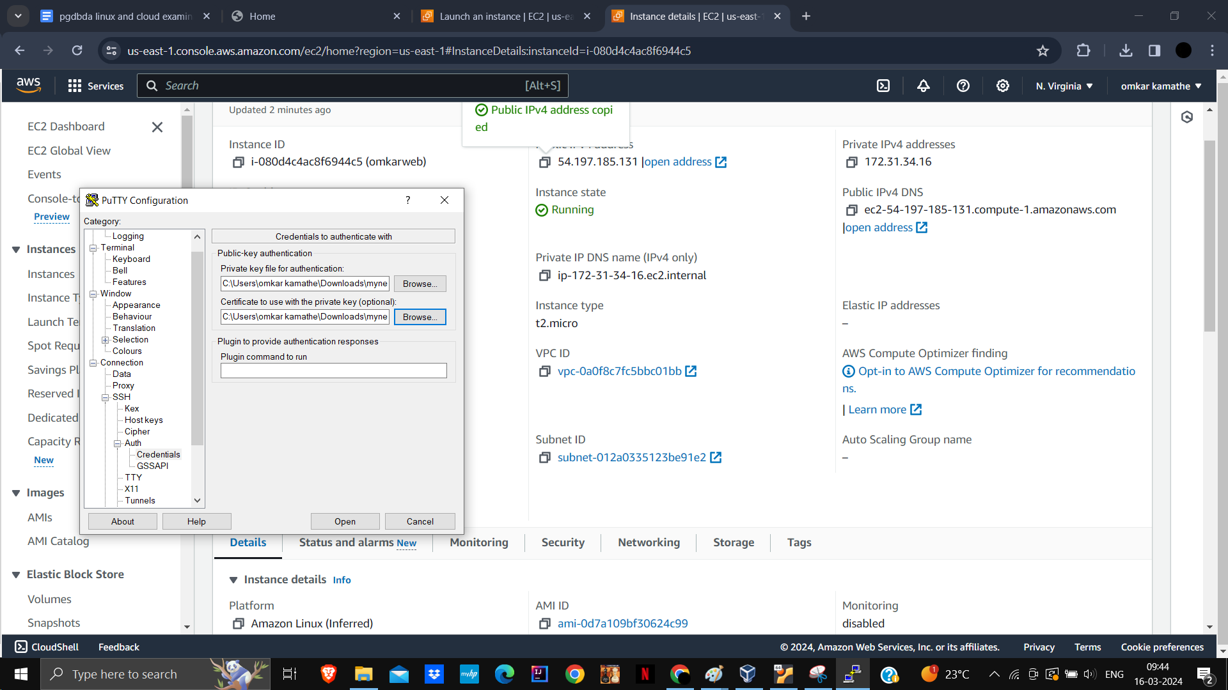

Sudo -i

Yum update -y

Yum install httpd iy

Systemctl start httpd

Systemctl enable httpd

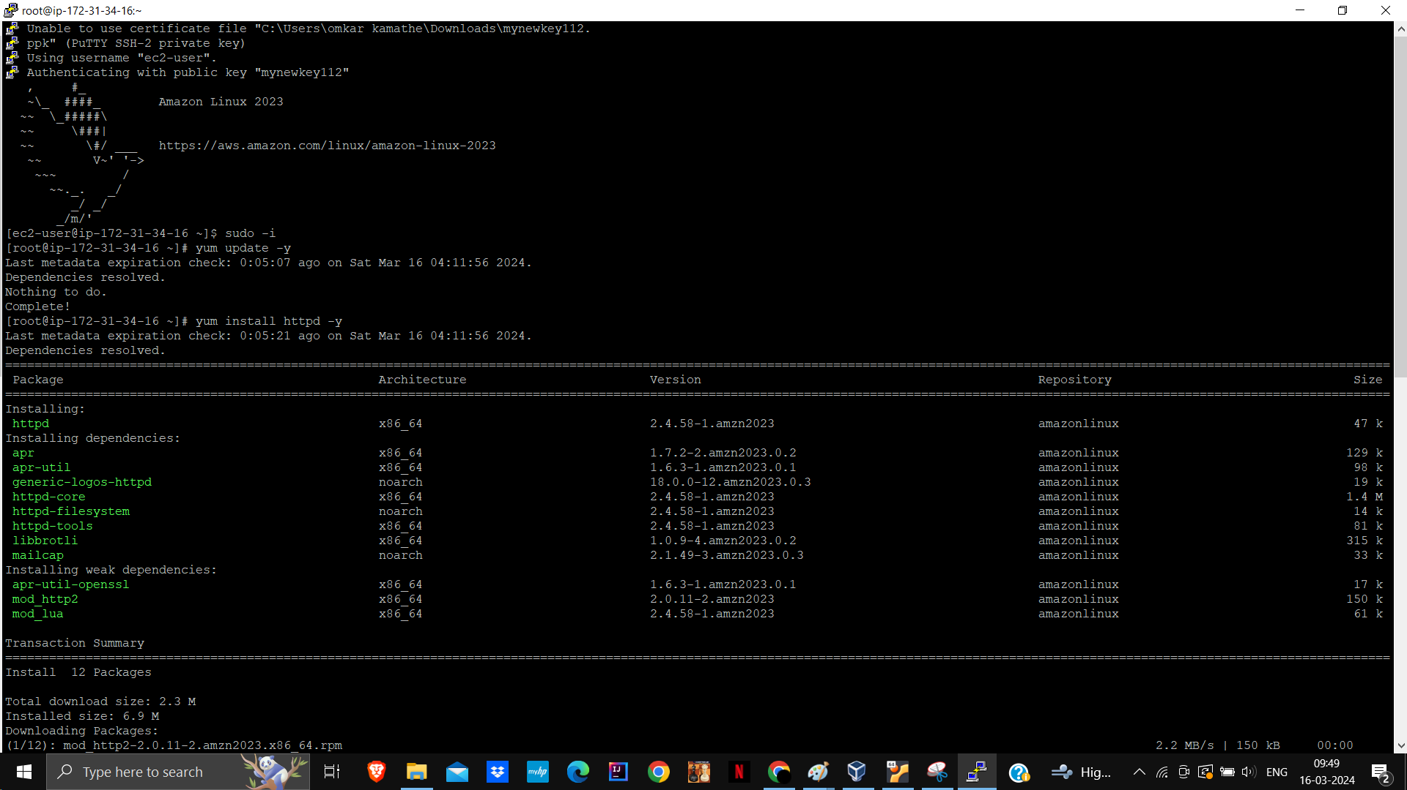

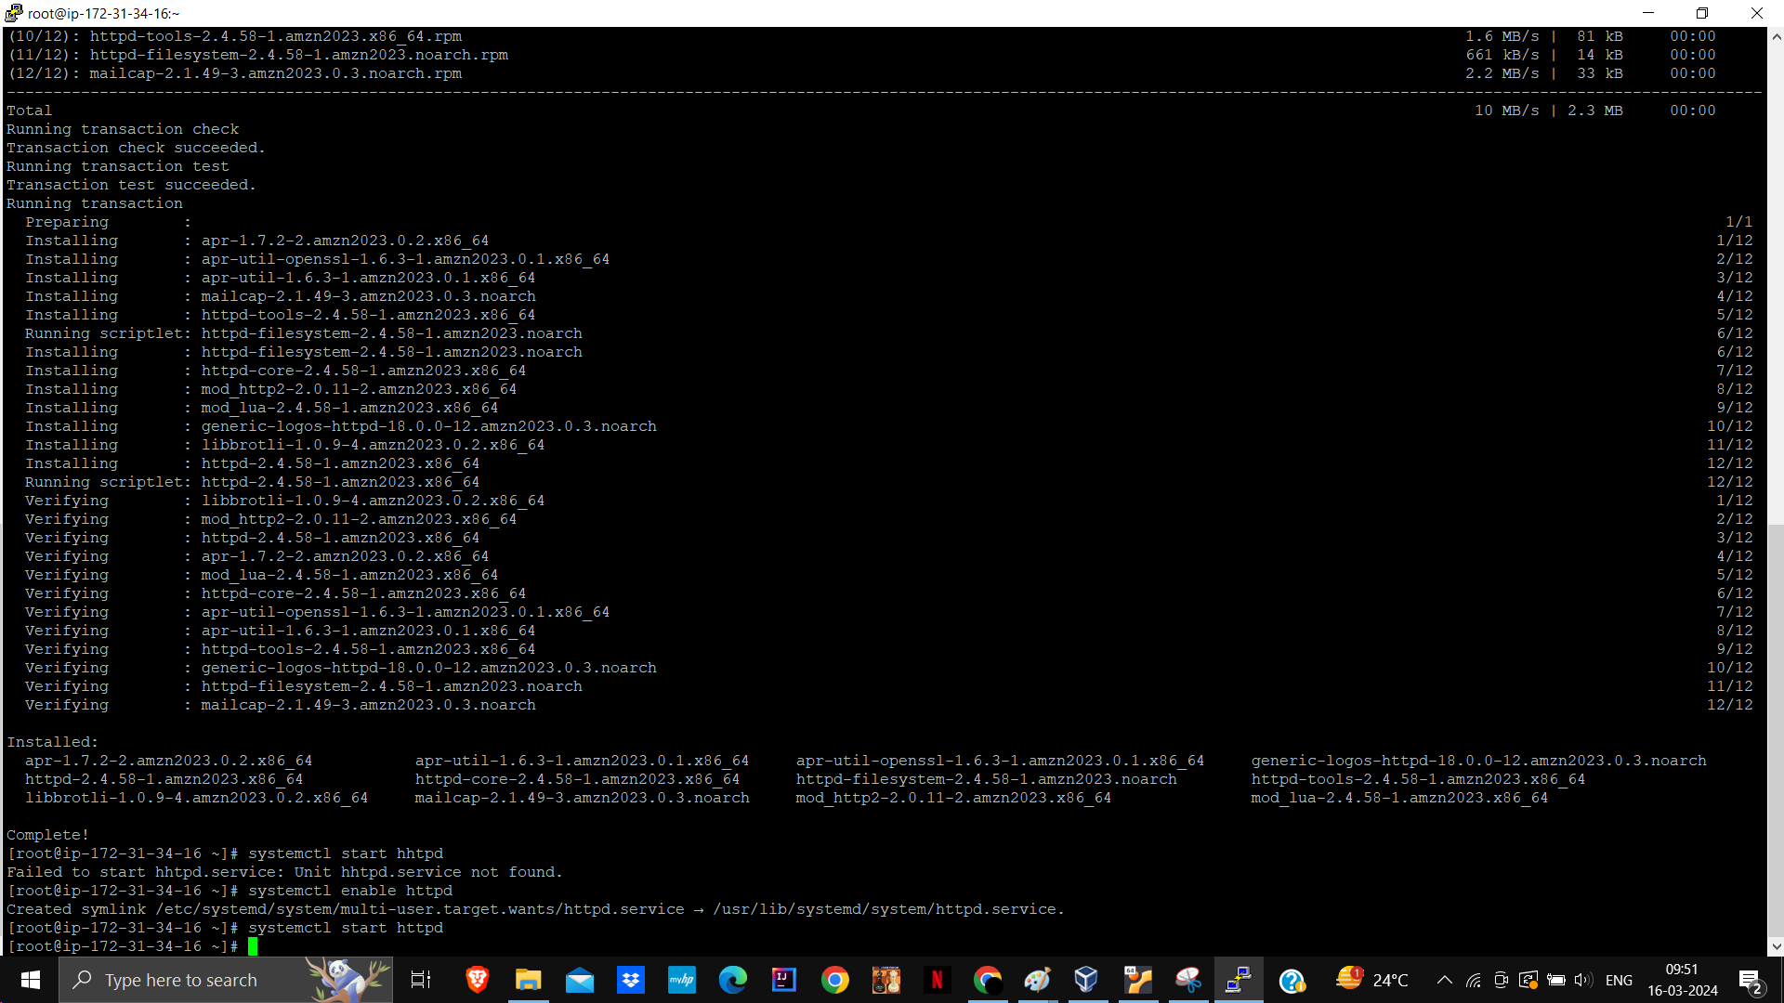

Write in index.html file in nano editor

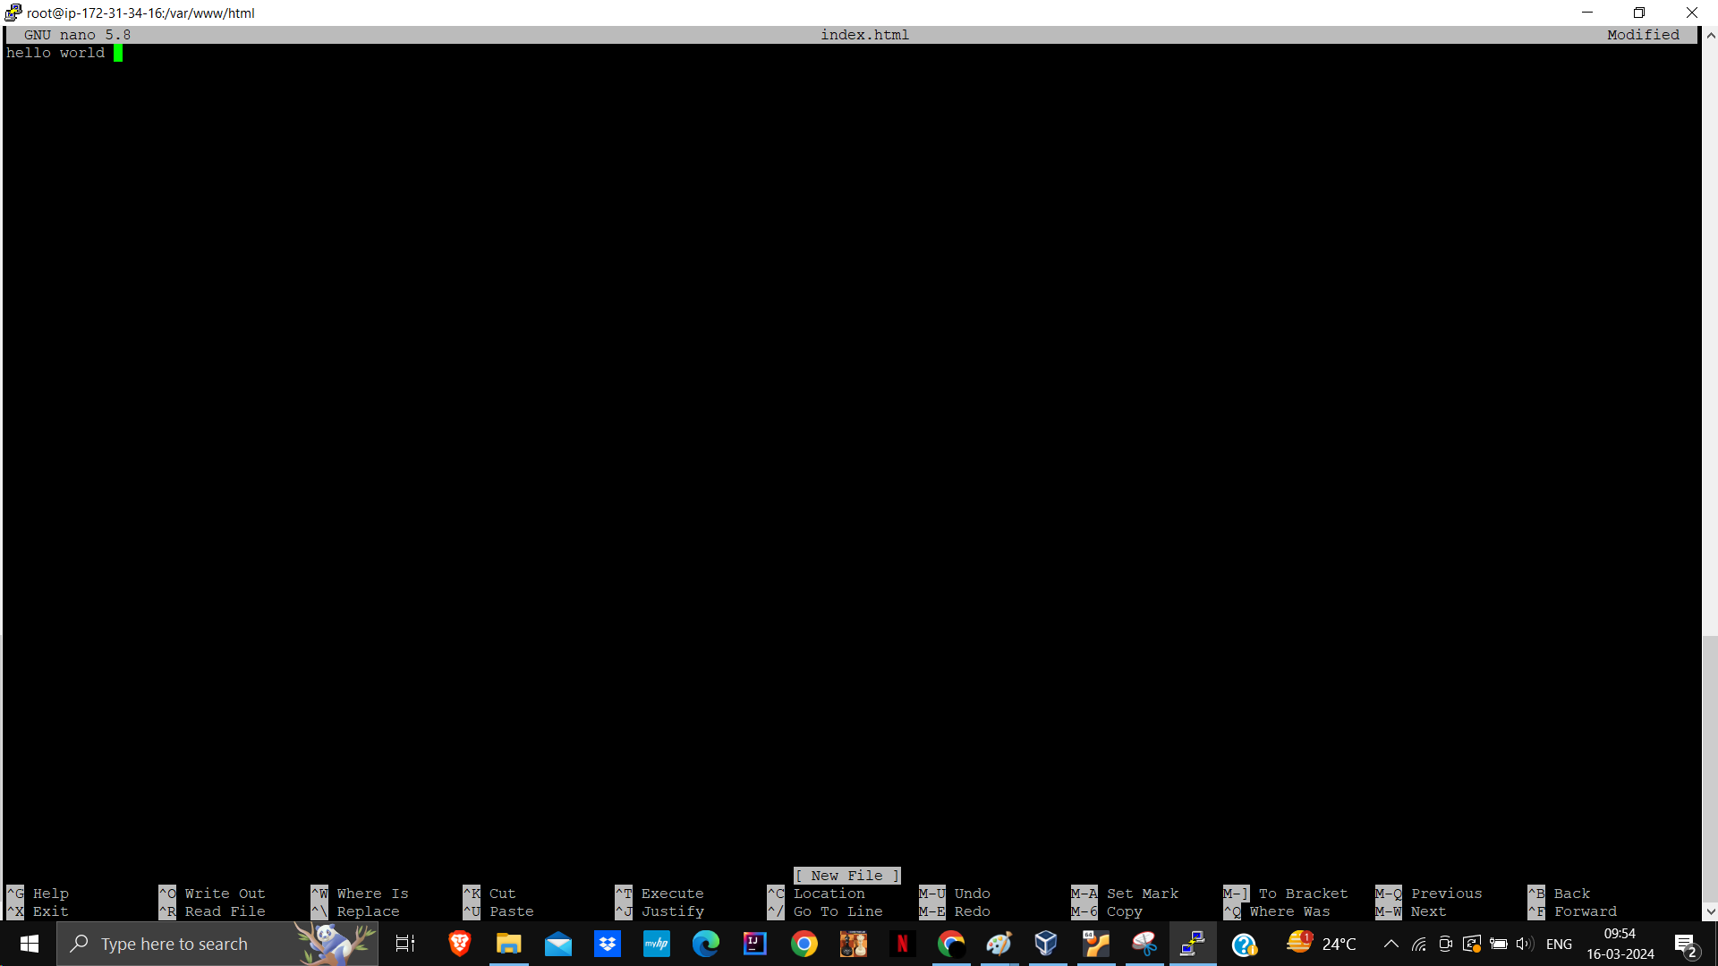

Copy pubic ip and paste

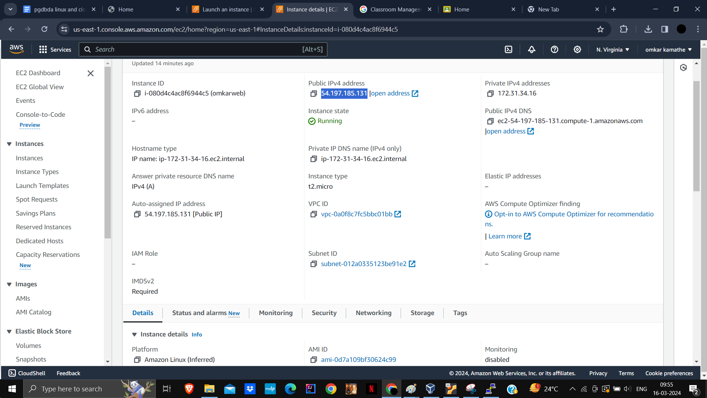

Message printed sucessfully

